Midnight Alterations: An Empire and Resistance Story
Built on Fate Core
Courtney Herber
University of Nebraska – Lincoln
Geoff Gimse
University of Wisconsin - Milwaukee

Introduction to the Story
This is a group heist style adventure set in the Empire and Resistance world where players will try to protect their family’s lands from seizure in the midst of a treacherous political climate. The adventure begins in the streets of Dublin and introduces players to Dublin City and eventually brings them into the walls of Dublin Castle. This adventure is designed for 3-5 players from any faction (see notes below for playing an unlanded or merchant character). The Fate Core book is a necessary accessory for this game. As an introductory adventure, Gamemasters should expect to take some time explaining the setting and the structure of play. We strongly encourage gamemasters to read through sourcebook material and provided links for information on Dublin prior to the Wars of the Three Kingdoms. Gamemasters should feel free to adapt the content and suggested FATE aspects to fit their group and their style of play.

Background
This story takes place in the spring or summer of 1640. At this point in time, Thomas Wentworth, earl of Strafford, also known as the Lord Deputy, is in residence at Dublin Castle. The Actons, a wealthy merchant family from Yorkshire, England with possible ties to Wentworth, have sent a proposal via the Lord Secretary asking that land under the ownership or protection of the player characters be ceded to them. Wentworth, anxious to build favor and power, would happily use his leadership on the Privy Council to make this happen. It is up to the player characters to stop this proposal from becoming law.
The practice of title/land confiscation and resale was not uncommon in early modern Ireland. It was a tactic used by the monarch to build support for themselves by either forcing the current owners to convert to Protestantism or kick them off their lands and sell to someone who would be loyal to Church and Crown.

The proposal now sits in Dublin Castle waiting for review. While the initial idea may be for the players to steal the document, this will not enough. If the players steal the document, the Actons will simply send another under greater guard. As the players discover the depth of the threat, they will realize that they have only one option. They must intercept the proposal and provide a new copy for the Lord Deputy and the Privy Council to approve, preferably one that will keep the Actons far away from the players’ lands.

Hook: From Land-rich to Lack-land
A knock at the door. A messenger in the dead of night. They braved their way through a spring thunderstorm to bring you a small, sealed letter.
GM Design Notes: See Appendix A & B for printable letters to give to your characters
The letter is from a servant in Dublin Castle, and one who is allied to one or several of the player characters. You decide to whom the letter is addressed – it may make sense to go to the character with the highest Contacts skill or for the character with the highest Assets. The gender and identification of the servant should be customized to best fit the character they are working for. If the player you select is one of the wealthier sort, any of the factions, then the letter is warning of a loss of their lands. This is Appendix A. If you choose a merchant or otherwise unlanded character, then the game becomes one of leverage and mercenary work, rather than protecting the lands of oneself or an ally. This is Appendix B. You can customize which lands are to be purchased from the character’s ally in the text. Both letters are written in such a way that maintains the verisimilitude of the early modern feeling with unorthodox spellings (as spelling was not entirely standardized in the seventeenth century).
The adventure is largely the same either way, it’s just the motivations that are shifted.

The letter contains information that the Acton family of the North Riding of Yorkshire, an upstart family of gentlemen wool merchants, are seeking to bolster their fortunes by buying an Irish title and the lands that come along with it.
The messenger also informs the players that the proposal, which would force the players or the players’ employer to ‘surrender’ your lands to the Crown has not made it yet to the Privy Council, who must approve of it before it is brought before the Parliament of Ireland.
After it is drafted, a proposal would be brought by the Lord Secretary to the Privy Council, or a small group of appointed men who perform administrative duties to run the kingdom, while also keeping the Lord Deputy abreast of goings on. After the Lord Secretary brings it to the Privy Council, if they approve of it (which there’s no reason why Wentworth would NOT approve it, as he’s looking to gain powerful allies in Yorkshire to sway the English Parliament, and as a former MP for Yorkshire, it’s his home territory and he probably knew the Actons personally or by reputation), then it would go before the two houses of Parliament for debate and approval.
GM Design Notes: In the game, we will assume that with Wentworth’s approval, Parliament would simply rubber-stamp approval on the measure. In a later, more complicated adventure, you could explore the intricacies of Parliamentary debate and procedure, but this is just a beginner’s adventure to immerse players in the world of Empire and Resistance.

Scene 1: Gathering Intel
While the players know the proposal has not made its way to the Privy Council yet, that doesn’t mean that Wentworth hasn’t seen it. Their job is to find a way to make sure he doesn’t see it.
The servant tells the players that the Privy Council is meeting at Dublin Castle sometime in the next few days, and that Wentworth will be in attendance. That’s all that they know, and they abscond back to the Castle before they’re missed.
The job of the players then, is to learn when the Privy Council is meeting, in which chambers the proposal will be held before it is reviewed by the Council, who has access to the proposal, and when all of this is going down.
GM Design Notes: While some of the characters would possibly have had dealings in the Castle and would be aware of the general layout, that doesn’t mean that they necessarily would have been admitted to the chambers where the Privy Council works. This means that none of the characters would know for a certainty where in the Castle the proposal will be, so gaining a map (most likely hand-drawn) or directions from someone in the know would be important for everyone. For a map of Dublin Castle, see Appendix C.

There are several ways to go about getting the information needed.
- Talk to someone in the Castle if the players have the Contacts. See what information the players can get from them.
- Hit up the local pubs or private drinking establishments to discreetly inquire as to who has knowledge of the Castle and could maybe draw a map (see Players Handbook for more information on pubs and drinking in Dublin).
- Case the Castle themselves in disguise to get to know the layout.
Once the players have all the information, the characters need to make a plan on how to get into the Castle.

Scene 2: Getting into the Castle
If your characters successfully gathered enough intel on the Castle, guard rounds, keys/locks, etc, the next step is getting past the keeps into the Castle grounds, but also into the chambers where the proposal will be written/processed.
Dublin Castle is like a little walled village. It has enough inside to hold out a siege of at least a few months, so it has towers where food and other necessary supplies are stored. The Castle is also home to three other important bodies – a regiment of the Lord Deputy’s soldiers, Parliament, and when in residence, the Lord Deputy himself. Times when Parliament meets (which is usually when the Lord Deputy is also in residence, as he opens and sometimes presides over Parliament) there would naturally be higher levels of security.
GM Design Notes: You may also wish to play out how your characters get to the Castle through the streets of Dublin without arousing suspicion. There would not be a police force in Ireland at this time (that came in the eighteenth century), but that doesn’t mean that there wasn’t street justice or an unofficial ‘neighborhood watch.’ If people thought you looked shady, they’d do something about it – unless you were able to bribe them or find another way to keep them quiet.

Different groups of players will come up with different ways of getting into the castle. If the party consists of an important nobleman/woman then perhaps they request an audience with someone stationed at the Castle and the others sneak in during a distraction or as part of the nobleman/woman’s entourage.
Other groups may not have a character with enough political power to request an audience with someone in the Castle (although it does matter with whom they request the audience! Some members of staff would be easier to get ahold of, but they wouldn’t be the best to request an audience with. Like the head cook – while he’d be easier to see, it might look rather odd to meet with him. Sending a servant to meet with him to ask for recommendations on a meal a character may host is one thing but having a nobleman/woman meet with the cook is just plain odd and suspicious), so they may just attempt to sneak in during a break in the guard’s cycle or cause a distraction and then enter.
GM Design Notes: Don’t forget the moats on the east and south walls of the Castle! There’s a little bit of dry land immediately to the south of the castle curtain walls, but it is surrounded by water.

Guards would normally be stationed at the main gate, the one to the north of the walls, as well as making rounds on the ramparts. For the sake of the game, we will say that there are always guards at the main gate (switched out every 4 hours) and the guards on the ramparts make rounds every 30 minutes (guards are expensive).
Make contested notice checks for the guards. Every guard has the “I Protect this Place with My Life” aspect that can be invoked as needed. As the elements of the scene evolve, feel free to add additional aspects, as needed.
If the team try a different way of getting into the Castle, like causing a distraction and running in the front gate or climbing over the walls, keep in mind how quiet they would need to be to not be caught. Scene aspects could include “Silent Night, Wary Guards” or “Was that a mouse?” providing additional challenges to players as they begin their approach. Also keep in mind that they’d only have a certain amount of time where the watercraft or supplies they’d used to get their way into the Castle would be found out (Aspect: “The Clock is Ticking”) .

Scene 3: In the Castle
Once the team gets into the Castle, they need to get their bearings and find the room where the proposal is held.
While the guard on the interior of the Castle chambers may be slightly less frequent than the walls, that doesn’t mean that there wouldn’t be many people bustling about. Keep that in mind as you set the scene.
Depending on when the team decides to do their daring heist, the Castle is poorly lit, dank, and generally quite dark (night), or slightly better lit and slightly less dank (day). Some of the rooms would have glass windows, but those are mostly the chambers where Parliament meets and where the Lord Deputy resides and meets with dignitaries/Privy Council (glass is super expensive). Most corridors or other rooms would have paneless windows with shutters that close securely or the thin cross-like windows that are great for shooting arrows from. There would be tapestries lining the walls as they help with both sonic and temperature insulation.
Finding the chamber may be difficult as in the Long Gallery there is a group of the Lord Deputy’s household having a meeting over dinner (the gallery has had a long table brought in and set up as a banquet in the middle of the room). They are talking about the public theatre that has just opened across the road on Saint Werburgh Street. In one of the many doors off the Long Gallery is a storage chamber that connects to the chamber where the proposal is held.
While there are at maybe 10 men having dinner, they are a loud and raucous bunch and they sound like at least 20 instead. That’s what you get for theatre types. If players have the sufficient Contacts, then they may know who some of these men are. There are two men who are more well-known than the others: John Ogilby, the Irish Master of the Revels (also tutor to the Wentworth’s children) and James Shirley, wannabe poet laurate and resident playwright of the Werburgh. The rest of the men are players in His Majesty’s Company of Comedians (the theatre troupe) and they help run all aspects of the theatre as it is a small operation.
The other way of getting to the scriptorium where the proposal is held is through the Lord Deputy’s personal residence chambers. One of the doors in the south wall of his larger room leads down a long corridor that ends in the scriptorium.
While the Lord Deputy may not be in his room, that doesn’t mean his family isn’t nearby or servants rushing about. At this time, his family consists of his third wife, Elizabeth (Aspect: “Haughty but easily frightened”), and three children from his second marriage and one from his third. At the time of our game, his children were William (14) (Aspect: “I am destined for more”), Anne (13) (Aspect: “Ireland is so boring!”), Arabella (10) and Margaret (age unknown, probably around 5).
GM Design Notes: His children would probably have a separate household within the Castle, nearby to Wentworth’s apartments. While it would be possible that Thomas would have kept separate private chambers from Elizabeth, this is unlikely given the size of the Castle. So she and her servants may be bustling about as well.

Scene 4: Finding and Changing the Proposal
Once the group has made their way through the corridors to the Privy Council’s room (the small chamber immediately to the south of the Lord Lieutenant’s Chambers), the task then is to find the copy of the proposal and either reword or replace it with a more acceptable version. There are many piles of deeds and proposals to sort through – the task made that much harder by only one small window high in the chamber. Any light provided comes from candles (unless the group attempts the switch during the daytime hours, then there is a bit of sunshine).
In the Council’s room, there is a long corridor to the north that connects it with the Lord Lieutenant’s chambers, there are doors on the west and south walls that lead to storage rooms near the Long Gallery (which is where the Lord Deputy showed off his growing collection of Italian and Dutch masters).
Historically speaking, the Privy Council wouldn’t necessarily have their own chambers in the Castle, but for the purposes of the game, they do. They would simply meet in a hall where there was enough room for all the members as well as doors that could be closed for privacy.
Once the group gains access to the room, they will need to search for the proposal on the wooden table that is already burdened with many other deeds and proposals. It would be a smaller – already sealed – letter.
This could go one of two ways:
The group opens and rewrites portions of the proposal. Even if it was drafted by a professional scribe (which it was) there could still have been places where mistakes were rubbed out or crossed out and written over.
The group has drafted a completely different proposal and intends to replace the legitimate one with their forged one.
In either case – there needs to be a reasonable copy of the official seal of Wentworth’s secretary on the document otherwise when the proposal is brought before the Privy Council they will know it’s been tampered with. The signature also needs to match. Luckily the seal should be easier to find/steal/make a copy of than the Great Seal of the Lord Deputy, which would go onto the document after it’s been approved by Parliament.

Scene 5: Getting Out of the Castle/Conclusion
Once the deed is done, it is time to make a daring escape! This must be done carefully, as if the team is discovered, there would be a thorough search of the chambers surrounding where the team was discovered to see what was missing or out of place. This is an excellent time to play the “Clock is ticking” aspect from earlier and force the players to move quickly or to have them run into a suspicious servant (Aspect: “I know everyone in this castle, but I don’t know you!”) who happens by. The players must escape without drawing notice to what they have done. If they are able to complete the mission, they can return home and wait for news of the proposal.

Where to Next:
While the players have averted the danger to their family, they may have also made some powerful enemies. It is very likely that the Actons will discover what has happened, or (if another family’s lands are offered instead) that a servant reports seeing the players in the castle, which could trigger an investigation by Wentworth. These rumors can create the next step in a broader story that draws the players into a more complex struggle for power and position in Ireland.

Hand-Outs and Game Resources

Appendix A: Letter to Landed Player Character
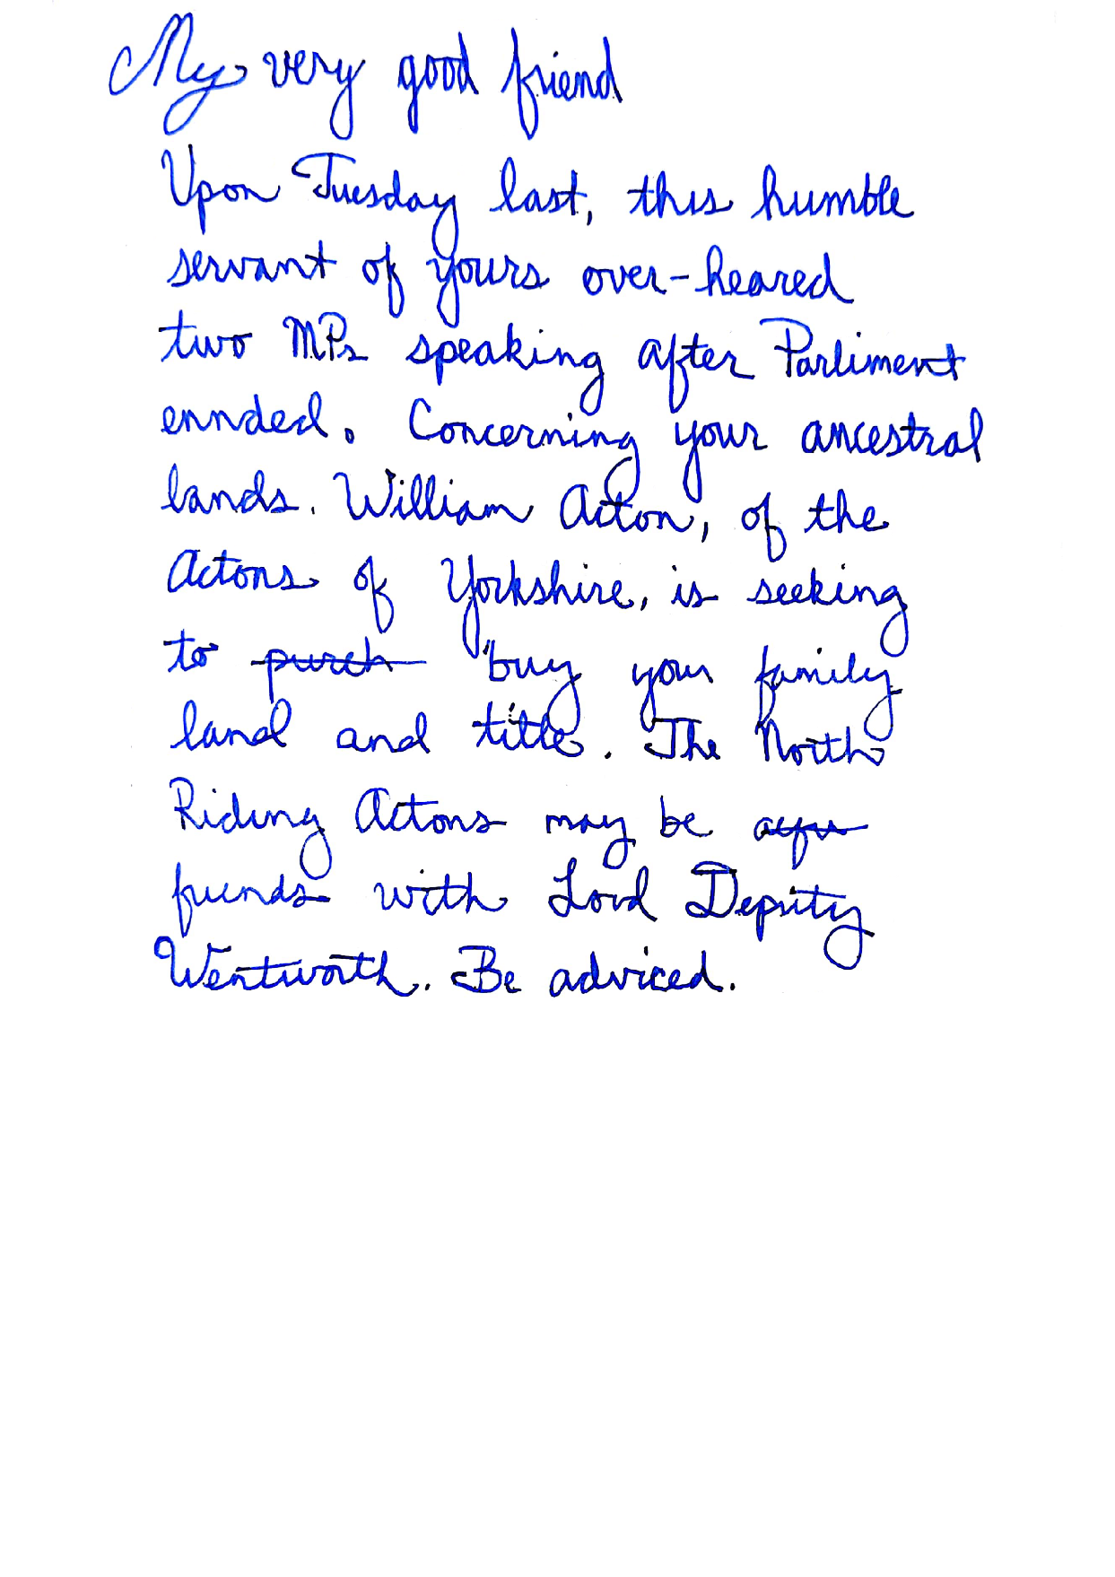

Appendix B: Letter to unlanded character
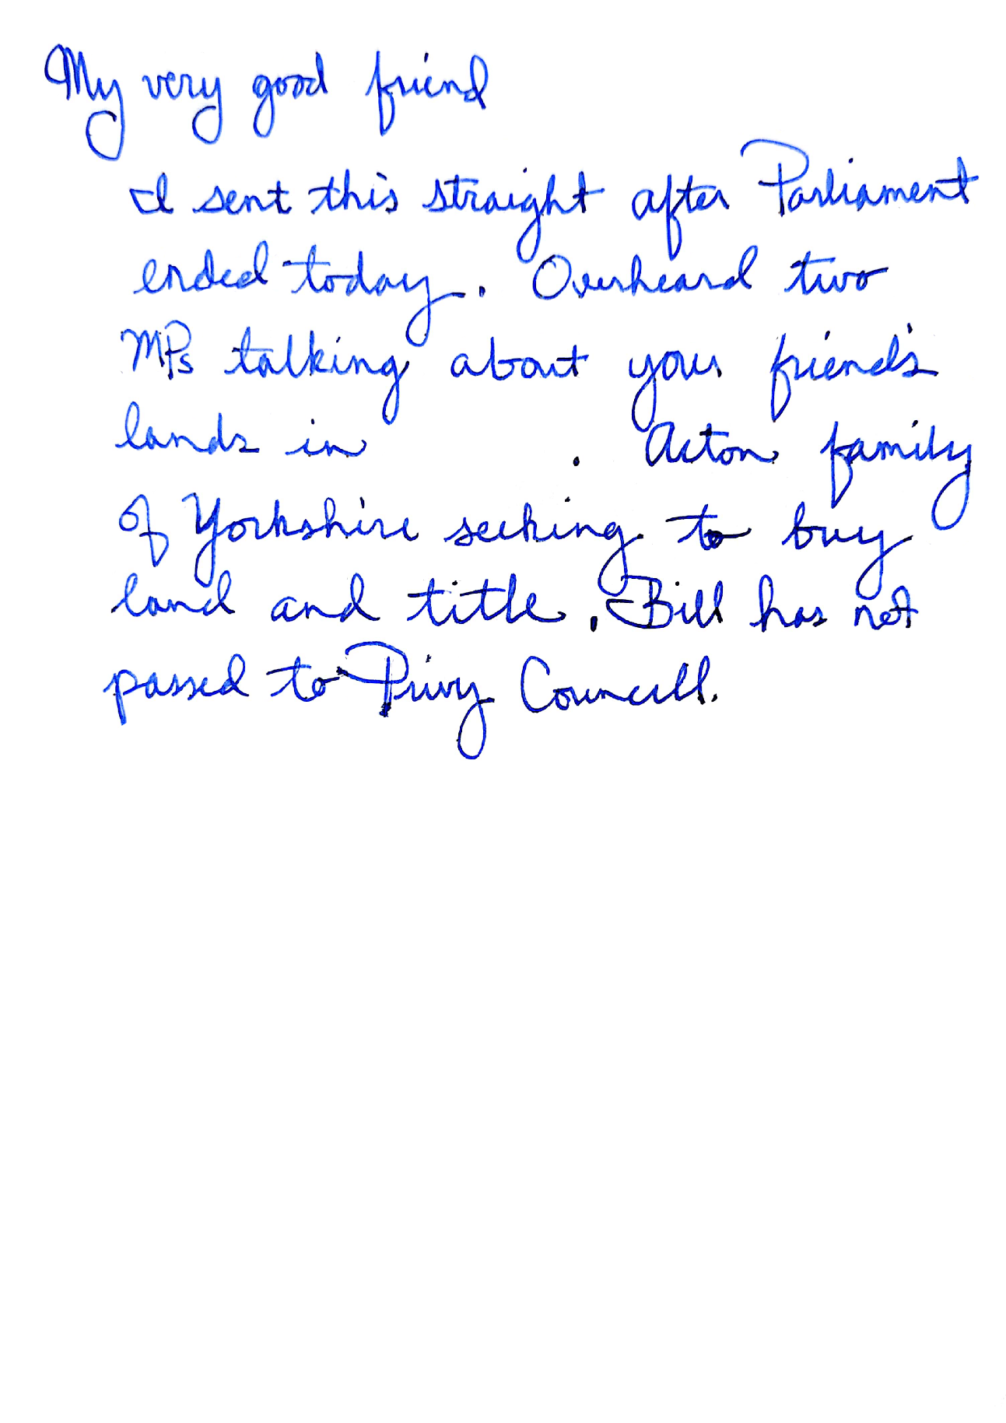

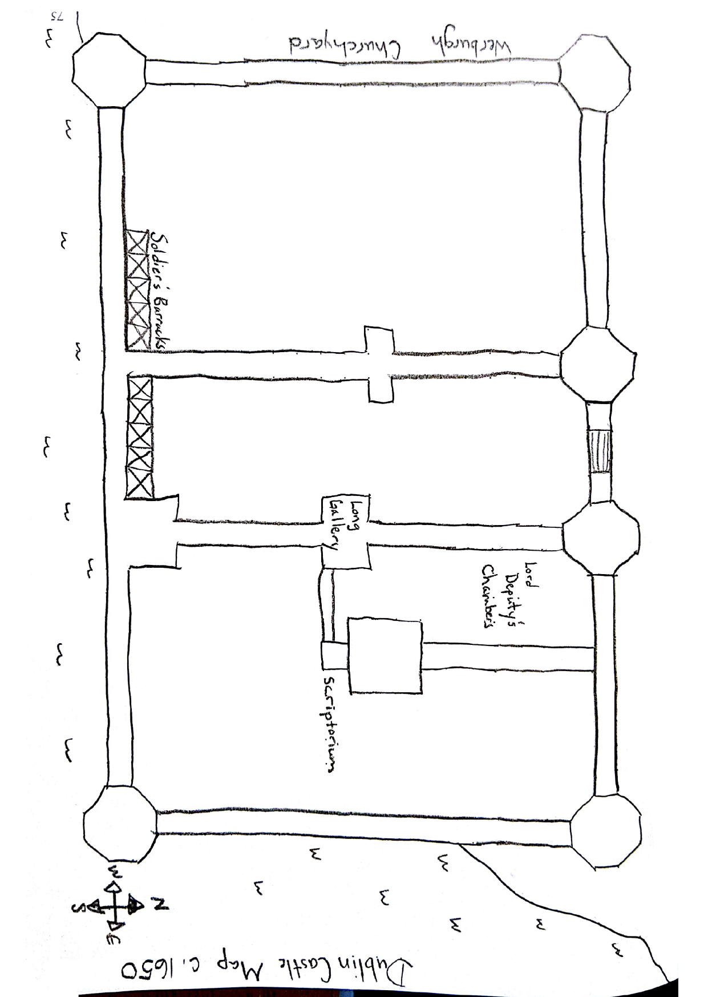
Appendix C: Map of Dublin Castle c. 1650

